FORM FOR MAKING REPRESENTATIONS ABOUT A COASTAL ACCESS REPORT
Any person may make a representation about a coastal access report.
This form should be completed if you wish to make a representation about the coastal access report which Natural England submitted to the Secretary of State for Environment, Food and Rural Affairs on 27th August 2025 under section 51 of the National Parks and Access to the Countryside Act 1949, pursuant to its duty under section 296(1) of the Marine and Coastal Access Act 2009. The report relates to
East Cowes Ferry to Wootton Bridge (Isle of Wight 1).
Any representations about the report must be made on this form and received by Natural England no later than 22nd October 2025. If you require more space for your comments, please continue on a separate sheet.
1. Please give the number of the report and number of the map to which the representation(s) relate(s):
Isle of Wight 1. Maps
1b New barn to Campfield Road,
1c Camfield Road to Brocks Copse Road.

2. If the representation(s) relate to specific land on the map(s), please describe the land here:
Pier Wood to Woodhouse Copse - Ramblers Map of Three Key Concerns:

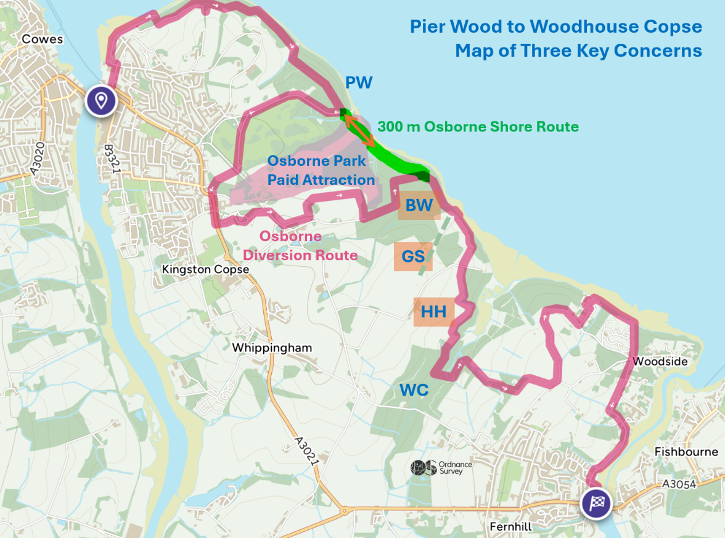

This Representation deals with three key concerns about providing an off-road route that
follows the coastline from Barton Wood, then runs along the boundary of Kings Quay
SSSI conservation area to reach the existing open access woodland of Woodhouse Copse.
BW Barton Wood SZ 5296 9496
GS Grass Airstrip SZ 5329 9453
HH High Health Cattle SZ 5336 9377

3. Please tick the appropriate box below to show who is making the representation(s), or on whose behalf you are making the representation(s):
An access authority for an area in which land to which the report relates is situated | £
A local access forum for an area in which land to which the report relates is situated | £
The Historic Buildings and Monuments Commission for England (English Heritage) | £
The Environment Agency | £
A person specified in Schedule 1 to the Coastal Access Reports (Consideration and Modification Procedure) (England) Regulations 2010 (S.I. 2010/1976) | £
Other (please give details): | Yes
4. If you have ticked the “other” box above, please also indicate if you are a person with a relevant interest (within the meaning of section 55J(2) of the National Parks and Access to the Countryside Act 1949^{(a)}) in land to which the report relates | None
5. Please give details of, and the reasons for, the representation(s) you are making about Natural England’s report:
We need to identify a practical coastal off-road route around this beautiful stretch of shoreline and countryside that complies with the provisions of the 2013 England Coast Path Scheme. Dependent on whether English Heritage agree to 300m of ECP running along the Osborne estate shoreline boundary, there are two potential routes shown on the map. However, both route options pass through Barton Wood, near the end of Barton Grass Airstrip, and along the boundary between Woodhouse Farm High Health Cattle fields with Kings Quay woodland.

BW - Barton Woods
This stretch of coastal wood borders the Osborne Estate, most of it has an Historic designation as part of Osborne Park. However, over several decades it was managed by the Forestry Commission for commercial production of conifers. It has no special conservation designation, and its shoreline is situated 1 km from Barton Manor and its gardens. The actual current status of this largely overgrown mixed woodland is not a ‘Private Park’ excepted from the England Coast Path access provisions. The national trail should be routed through Barton Woods, and it should provide coastal margin open access.

GS - Barton Grass Airstrip
Around 2018 an unsurfaced airstrip was laid out across two areas of grassland ending near a SSSI shoreline. It has no formal planning permission. The strip has been located next to a permanent agricultural building; trees have been cleared through an area of woodland to create a narrow gap for the strip. Aircraft take off and land over a SSSI seabird nesting area. The legal operation of this facility needs to be verified against the general regulations for 28 day each year temporary use of land permitted development.
Can such an arrangement be classified as an excepted Aerodrome blocking a national Trail along this coastline?

HH - High Health Cattle Woodhouse Farm Grazing fields.
For the proposed west- east route alongside Woodside Farm High Heath Cattle grazing fields IOW1 S041. Natural England are proposing suitable fencing to separate High Health Cattle from people and dogs.
For this part of the practical coastal route that would need to run north-south along
the border between Kings Quay woodland and Woodhouse Farm fields the same specification of fencing could be used to achieve cattle and people separation.

In conclusion the practical coastal route between Barton Woods and Wood House Copse
Should be used for the KCIII England coast Path route.

- Please list below any documents or evidence you have included in support of the representation(s):
Pier Wood to Woodhouse Copse - Ramblers Map of Three Key Concerns is attached

- Have you made any other representations about the report?
Yes £
No £
- If you are a person with a relevant interest in land to which the report relates, have you made any objection(s) which relate(s) to that land?
Yes £
NA

- Please complete your details below:
Name:
Organisation/company (if appropriate): | None
Address (including post code):
Telephone:
E-mail:
Date:
- mailto:southcoastalaccess@naturalengland.org.ukThe completed form should preferably be emailed to Natural England at:

southcoastalaccess@naturalengland.org.uk

or posted to
King Charles III England Coast Path team
Horizon House
Deanery Road
Bristol
BS1 5AH
(but must arrive no later than the first postal delivery after the closing date)

(a) Section 55J(2) provides that a person has a relevant interest in land if the person is the owner of the land, holds a term of years absolute in the land, or is in lawful occupation of the land.

